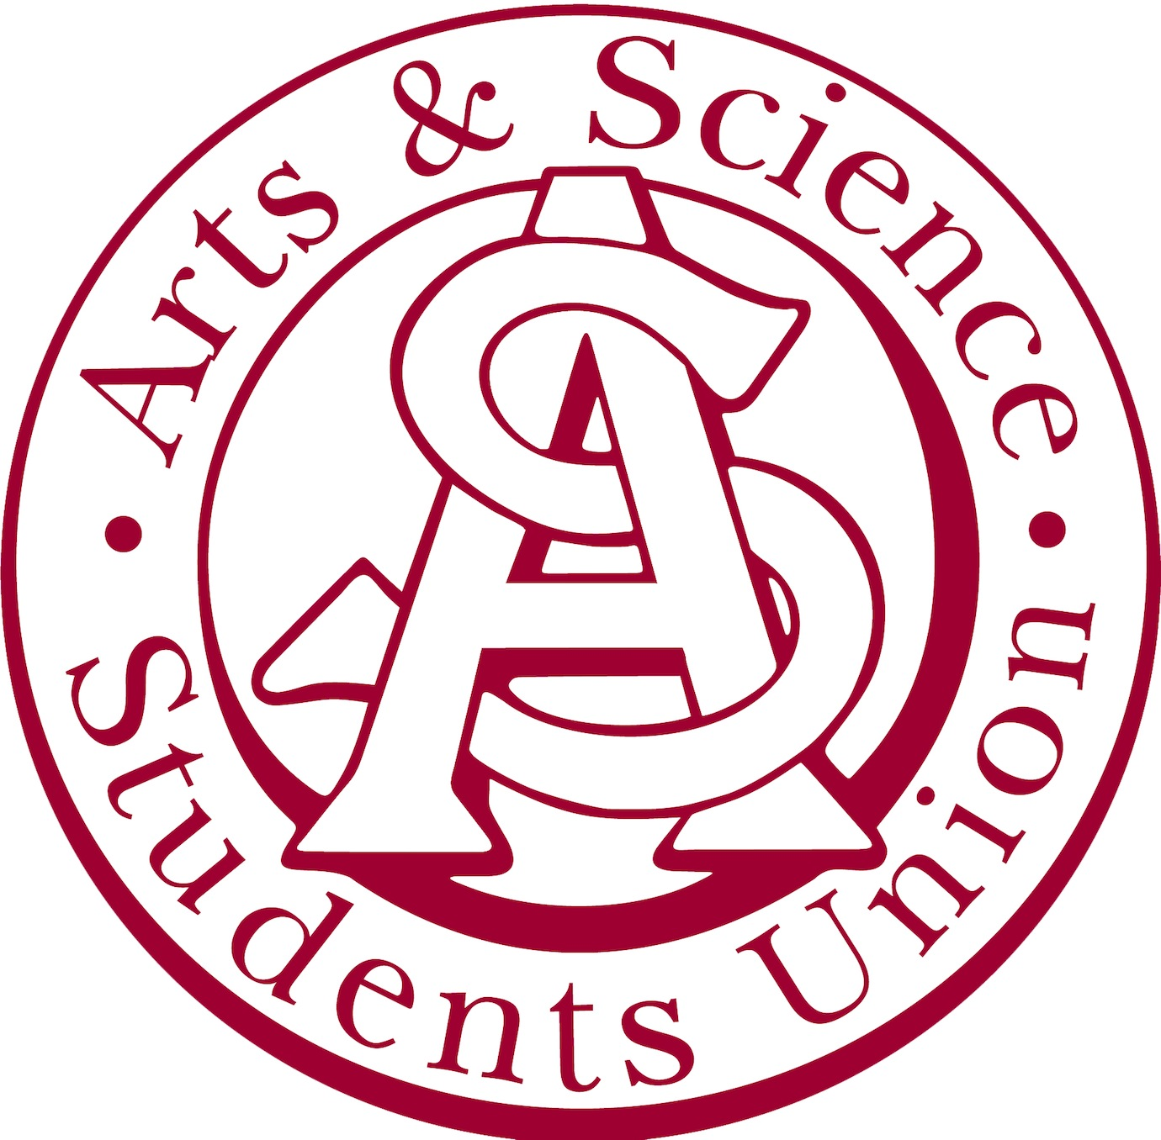
Arts & Science Students’ Union Agenda
September 25th , 2017

Regrets: Kirti Garg, Raquel Alvarado, Tasnim Jaisee, Logan Huard, Marcel Laforge
51 present.
Travis recognized that we are on treaty 6 territory
- Motion to Adopt the Agenda
    - Motion by Tanner
    - Seconded by Marcel
- Presidential Report
  - Addressed the new members
  - Addressed how the structure of meetings have changed. Now every other week will focus on council meetings, and the filler meetings will be committee meetings.
  - Peta-Bonham Smith wants to have a meaningful consultation with our students’ union. Will take place on October 30th
- Committee Reports
  - External Report. VP Bayne
    - The date of the social was decided with a poll on our Facebook page.
    - For those who are unaware, there is an event page on facebook for the social.
      - Not mandatory attendance
    - The ASSU is liable. Reminded participants to not drink to excess, please drink in moderation. We push for respect. Privileges to these things can be revoked.
  - Academic Report. VP Paradzik
    - Introduced herself to new comers.
    - Not a lot on the plate that the council is involved with
    - Scholarship
      - The applications of the scholarship will begin in the middle of October
      - Applicants may apply until December
      - Announcement of the winner will be in the middle to end of January
    - In contact with Arts and Science Administration
    - Someone from her committee to maybe take her place in the meetings with Administration
    - She will be at the meetings for academic misconduct meetings
  - Marketing. VP Klatt
    - Ice cream float giveaway, on Thursday around late morning
    - Details on an upcoming event page
  - Internal. VP Guan
    - The budget is the money we set to every year for each committee
    - Announced this new budget
    - Compared to last year, we have taken down the money towards the first years
    - Compared to last year
      - Marketing budget stayed the same
      - Academic received 400 more dollars
      - External received 150 more dollars
      - Internal went down by 2000 dollars
    - Previous budget was 14100$ , now is 12100$
    - Always promote transparency in the meetings.
- MSC Report.
  - Given by: Kylie, Kirsten and Aidan
    - Ai.
      - For each student it is an increase of 3000 dollars
      - With Whisk, on October 4th at 7pm there will be a paint night
      - Instructor tells you how to paint
      - It is not an 19+ event. All ages, just don’t buy liquor
    - Ky.
      - Ussu has been involved with the city and city council. Deon went to a meeting. Did a lot voting on meeting up with the university. They want students to come out for meetings in 2018. We can find information on the U of S. October second by 5 pm
      - In anyone followed budget cuts last year. Usually budget cuts are 6% and 20 million went to medicine. But they reversed the 20 million
    - Ki.
      - The fight isn’t over. If it something you are not cool with. Join USSU on Friday at 12:30 pm downtown.
      - There is a really cool conference this week. Global connections. Bringing student leaders together across the university. Indigenous content as well. Message Kirsten aswell.
- ISC Report
  - Meeting on Monday, with Peta, bringing up concepts of indigenise campus. Another meeting with Charlie Clark.
  - Office located in aboriginal students centre
  - Adam Beech, an indigenous Hollywood actor, will be giving a presentation to the college on Monday October 2nd.
- Questions and Comments

- Motion to adjourn the meeting
  - Henry
  - Seconded by Emily

